UROP PROJECT
M.Mahaboob Basha
AP22110020140
ECE-B

TASK-1
The Task 1 is to collect the data from the sensors and process it in the ESP-32 and show the output in a display
Circuit diagram:

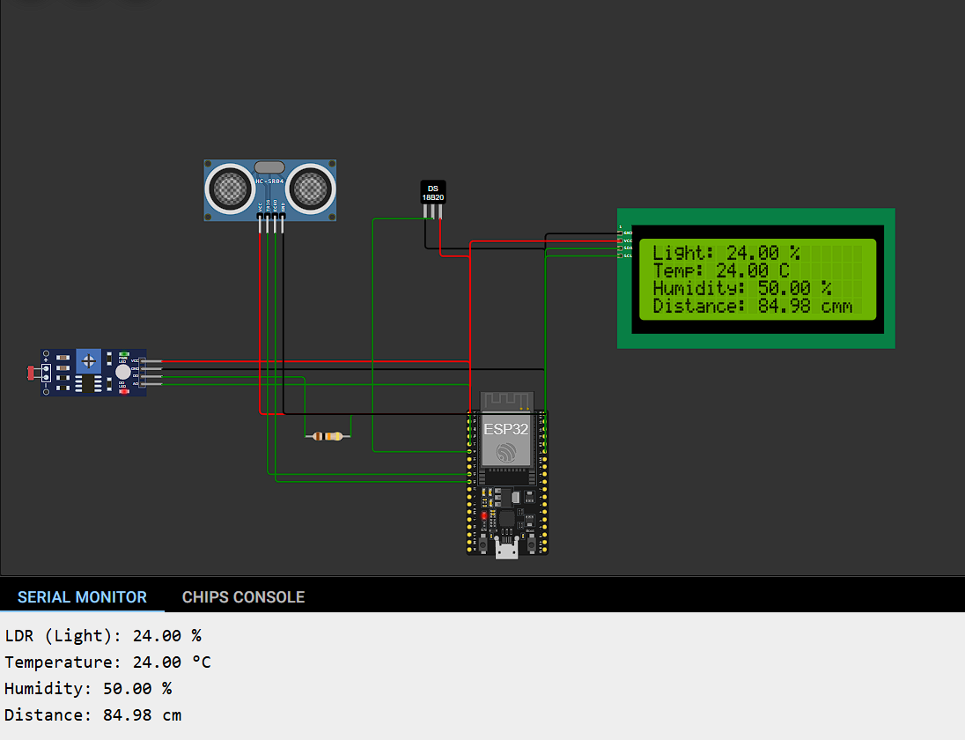

Code:
#include <Wire.h>
#include <LiquidCrystal_I2C.h>
// Initialize the LCD (address 0x27, 20 columns, 4 rows)
LiquidCrystal_I2C lcd(0x27, 20, 4);
// Sensor pins
const int ldrPin = 34; // LDR signal pin (analog)
const int tempPin = 35; // Temperature sensor pin (analog)
const int humPin = 32; // Humidity sensor pin (analog)
const int trigPin = 25; // Ultrasonic sensor Trig pin
const int echoPin = 26; // Ultrasonic sensor Echo pin
// Variables to store sensor readings
float lightLevel = 0;
float temperature = 0;
float humidity = 0;
float distance = 0;
void setup() {
Serial.begin(115200);
// Initialize LCD
lcd.init();
lcd.backlight();
// Set up ultrasonic sensor pins
pinMode(trigPin, OUTPUT);
pinMode(echoPin, INPUT);
// Display initialization message
lcd.setCursor(0, 0);
lcd.print("Initializing...");
delay(2000);
lcd.clear();
}
void loop() {
// Read LDR, temperature, and humidity
lightLevel = map(analogRead(ldrPin), 0, 4095, 0, 100); // Light level in %
temperature = map(analogRead(tempPin), 0, 4095, 0, 24); // Adjust based on sensor range
humidity = map(analogRead(humPin), 0, 4095, 0, 100); // Humidity in %
// Measure distance using ultrasonic sensor
digitalWrite(trigPin, LOW);
delayMicroseconds(2);
digitalWrite(trigPin, HIGH);
delayMicroseconds(10);
digitalWrite(trigPin, LOW);
long duration = pulseIn(echoPin, HIGH);
distance = (duration * 0.034) / 2; // Convert to cm
// Print values to Serial Monitor
Serial.print("LDR (Light): "); Serial.print(lightLevel, 2); Serial.println(" %");
Serial.print("Temperature: "); Serial.print(temperature, 2); Serial.println(" °C");
Serial.print("Humidity: "); Serial.print(humidity, 2); Serial.println(" %");
Serial.print("Distance: "); Serial.print(distance, 2); Serial.println(" cm");
Serial.println("---------------------------");
// Display readings on the LCD
lcd.setCursor(0, 0);
lcd.print("Light: ");
lcd.print(lightLevel, 2);
lcd.print(" %");
lcd.setCursor(0, 1);
lcd.print("Temp: ");
lcd.print(temperature, 2);
lcd.print(" C");
lcd.setCursor(0, 2);
lcd.print("Humidity: ");
lcd.print(humidity, 2);
lcd.print(" %");
lcd.setCursor(0, 3);
lcd.print("Distance: ");
lcd.print(distance, 2);
lcd.print(" cm");
delay(2000); // Update every 2 seconds
}

TASK-2:
The Task 2 is to take the inputs from the keypad and process it in the ESP-32 and show the output in a display

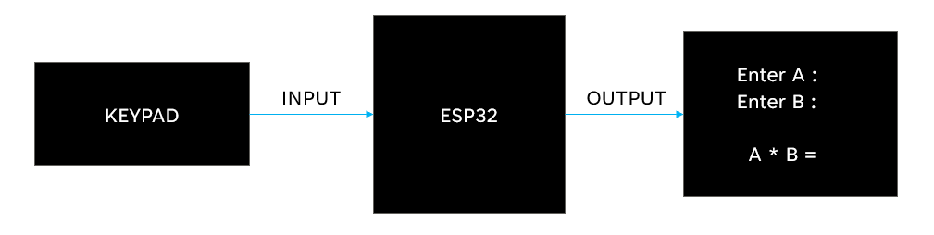
Block-diagram:
CONNECTIONS:
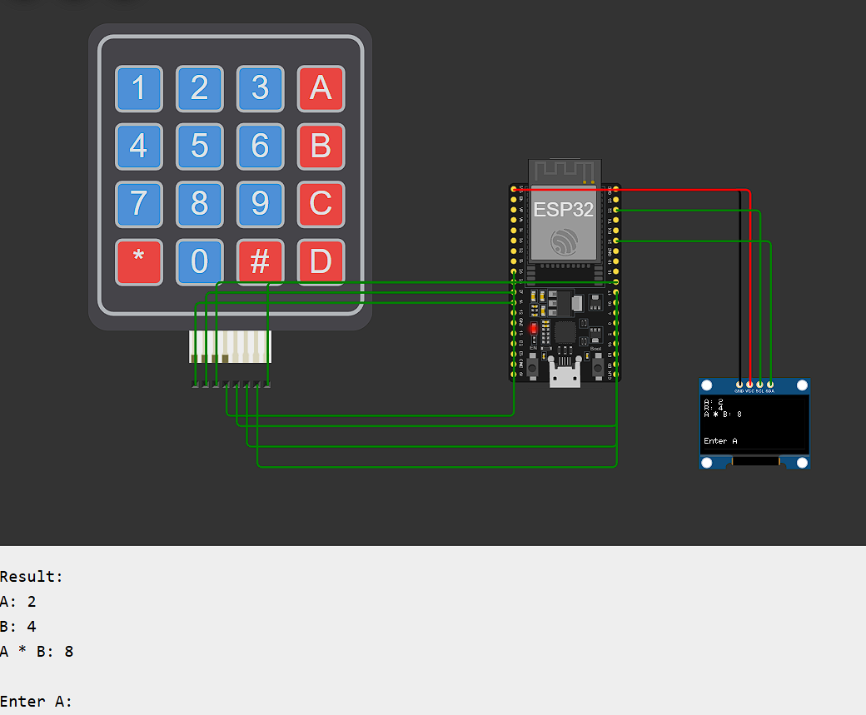

RESULT:
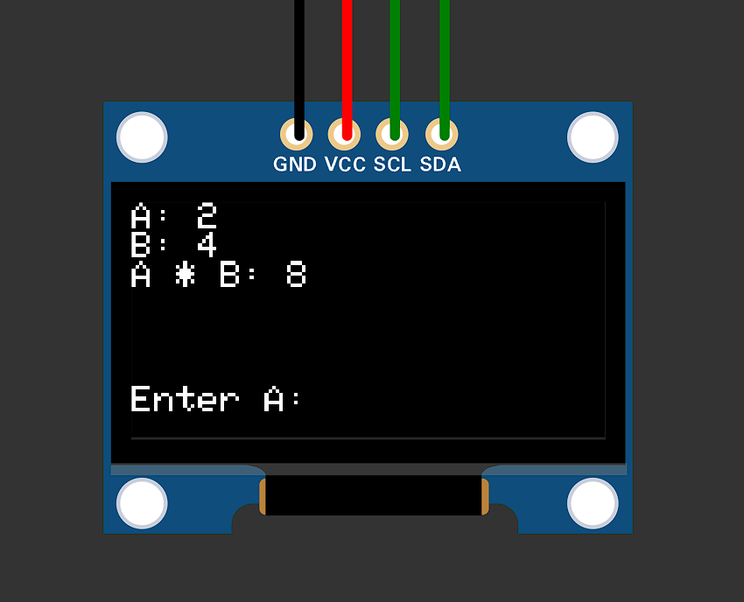
CODE:
#include <Wire.h>
#include <Adafruit_GFX.h>
#include <Adafruit_SSD1306.h>
#include <Keypad.h>
#define SCREEN_WIDTH 128
#define SCREEN_HEIGHT 64
Adafruit_SSD1306 display(SCREEN_WIDTH, SCREEN_HEIGHT, &Wire, -1);
const byte ROWS = 4, COLS = 4;
char keys[ROWS][COLS] = {
{'1', '2', '3', 'A'},
{'4', '5', '6', 'B'},
{'7', '8', '9', 'C'},
{'*', '0', '#', 'D'}
};
byte rowPins[ROWS] = {14, 27, 26, 25};
byte colPins[COLS] = {4, 16, 17, 5};
Keypad keypad = Keypad(makeKeymap(keys), rowPins, colPins, ROWS, COLS);
String inputA = "", inputB = "";
bool isInputtingA = true;
void setup() {
Serial.begin(115200);
if (!display.begin(SSD1306_BLACK, 0x3C)) for (;;);
display.clearDisplay();
display.setTextSize(1);
display.setTextColor(SSD1306_WHITE);
display.setCursor(0, 0);
display.println("Enter A:");
display.display();
Serial.println("Enter A:");
}
void loop() {
char key = keypad.getKey();
if (key) {
if (key == '#') {
if (isInputtingA) {
display.clearDisplay();
display.setCursor(0, 0);
display.println("Enter B:");
display.display();
Serial.println("\nEnter B:");
isInputtingA = false;
} else {
int a = inputA.toInt(), b = inputB.toInt();
int result = a * b;
display.clearDisplay();
display.setCursor(0, 0);
display.print("A: ");
display.println(a);
display.print("B: ");
display.println(b);
display.print("A * B: ");
display.println(result);
display.display();
Serial.println("\nResult:");
Serial.print("A: ");
Serial.println(a);
Serial.print("B: ");
Serial.println(b);
Serial.print("A * B: ");
Serial.println(result);
inputA = inputB = "";
isInputtingA = true;
display.setCursor(0, 50);
display.println("Enter A:");
display.display();
Serial.println("\nEnter A:");
}
} else if (key == '*') {
if (isInputtingA) inputA = ""; else inputB = "";
display.clearDisplay();
display.setCursor(0, 0);
display.println("Cleared input.");
display.display();
Serial.println("\nCleared input.");
} else {
if (isInputtingA) {
inputA += key;
display.clearDisplay();
display.setCursor(0, 0);
display.print("A: ");
display.println(inputA);
display.display();
Serial.print("\rA: ");
Serial.println(inputA);
} else {
inputB += key;
display.clearDisplay();
display.setCursor(0, 0);
display.print("B: ");
display.println(inputB);
display.display();
Serial.print("\rB: ");
Serial.println(inputB);
}
}
}
}
TASK-3
To calculate the Power, Charging Time in hr, Available power of the entered vehicle
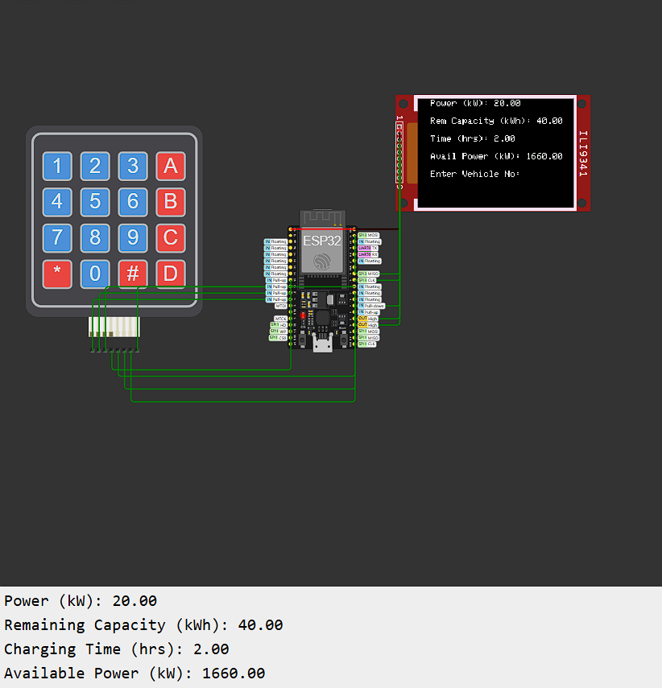
CONNECTIONS:
Output:
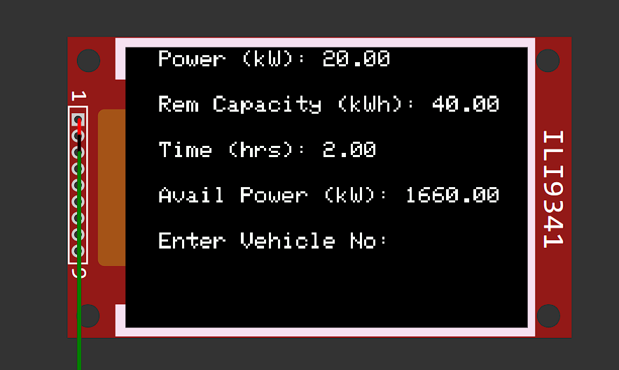
Inputs:
- Vehicle Number: AB01CD1234
- Car Battery Capacity: 50 kWh
- Battery Voltage: 400 V
- Current: 50 A
- Available SOC (State of Charge): 20%

Calculations:
Power (in kW):
The formula for power is:
P= V×I
Where:
V = 400 V
I = 50 A
P = 400 × 50 = 20,000 W
Thus, the charging power is 20 kW.
Remaining Capacity:
Remaining Capacity=Total Capacity×(1−(SOC/100)​)
Total Capacity = 50 kWh (Battery Capacity).
SOC = 20% (Available State of Charge).
Remaining Capacity = 50 × (1−(20/100))
=50×0.8
=40 kWh
Thus, the remaining capacity is 40 kWh
Charging Time (in Hours):
T= Remaining Capacity​ / Charging Power
Remaining Capacity = 40 kWh
Charging Power = 20 kW
T = 40 / 20 = 2 hours
Thus, the time required to charge the battery to full is 2 hours.
Available Power (in kWh):
This is calculated based on a total of 70 kWh of energy available, multiplied by 24 hours:
Total Power = 70 × 24 = 1680.0 kWh
Available Power (kW)=Total Power (1680 kW) − Power (kW)
= 1680 kW – 20 kW
= 1660 kW

CODE:
#include <Adafruit_GFX.h>
#include <Adafruit_ILI9341.h>
#include <Keypad.h>
// Pin Definitions for ILI9341
#define TFT_CS 15
#define TFT_DC 2
#define TFT_RST 4
// Create the display object
Adafruit_ILI9341 tft = Adafruit_ILI9341(TFT_CS, TFT_DC, TFT_RST);
// Keypad configuration
const byte ROWS = 4;
const byte COLS = 4;
char keys[ROWS][COLS] = {
{'1', '2', '3', 'A'},
{'4', '5', '6', 'B'},
{'7', '8', '9', 'C'},
{'*', '0', '#', 'D'}
};
byte rowPins[ROWS] = {14, 27, 26, 25};
byte colPins[COLS] = {4, 16, 17, 5};
Keypad keypad = Keypad(makeKeymap(keys), rowPins, colPins, ROWS, COLS);
// Variables
String vehicleNo = "";
String carBatteryKwh = "";
String batteryVoltage = "";
String current = "";
String availableSOC = "";
int currentStage = 0; // Tracks input stage
// Constants
const float TOTAL_POWER = 1680.0; // Total available power in kW
void setup() {
Serial.begin(115200); // Start Serial Monitor at 115200 baud rate
tft.begin();
tft.setRotation(1);
tft.fillScreen(ILI9341_BLACK);
tft.setTextColor(ILI9341_WHITE);
tft.setTextSize(2);
tft.setCursor(0, 0);
tft.println("Enter Vehicle No:");
// Debugging print to Serial Monitor
Serial.println("Enter Vehicle No:");
}
void loop() {
char key = keypad.getKey();
if (key) {
if (key == '#') { // Confirm input
currentStage++;
tft.fillScreen(ILI9341_BLACK);
tft.setCursor(0, 0);
switch (currentStage) {
case 1:
tft.println("Enter Car Battery:");
Serial.println("Enter Car Battery (kWh):");
break;
case 2:
tft.println("Enter Voltage:");
Serial.println("Enter Voltage (V):");
break;
case 3:
tft.println("Enter Current:");
Serial.println("Enter Current (A):");
break;
case 4:
tft.println("Enter SOC:");
Serial.println("Enter Available SOC (%):");
break;
case 5:
// Perform calculations for power and charging time
float batteryCapacity = carBatteryKwh.toFloat();
float voltage = batteryVoltage.toFloat();
float currentValue = current.toFloat();
float soc = availableSOC.toFloat();
// Calculate power (P = V * I) and charging time (T = remaining capacity / power)
float power = (voltage * currentValue) / 1000.0; // Power in kW
float remainingCapacity = batteryCapacity * (1 - (soc / 100.0)); // Remaining capacity in kWh
float chargingTime = remainingCapacity / power; // Charging time in hours
// Calculate available power
float availablePower = TOTAL_POWER - power;
// Display results with spacing on TFT display
tft.fillScreen(ILI9341_BLACK);
tft.setCursor(0, 0);
tft.print("Power (kW): ");
tft.println(power, 2);
tft.setCursor(0, 40); // Add vertical spacing
tft.print("Rem Capacity (kWh): ");
tft.println(remainingCapacity, 2);
tft.setCursor(0, 80); // Add vertical spacing
tft.print("Time (hrs): ");
tft.println(chargingTime, 2);
tft.setCursor(0, 120); // Add vertical spacing
tft.print("Avail Power (kW): ");
tft.println(availablePower, 2);
// Output results to Serial Monitor
Serial.println("Power (kW): " + String(power, 2));
Serial.println("Remaining Capacity (kWh): " + String(remainingCapacity, 2));
Serial.println("Charging Time (hrs): " + String(chargingTime, 2));
Serial.println("Available Power (kW): " + String(availablePower, 2));
// Reset inputs
vehicleNo = carBatteryKwh = batteryVoltage = current = availableSOC = "";
currentStage = 0;
tft.setCursor(0, 160); // Final line for new prompt
tft.println("Enter Vehicle No:");
break;
}
} else if (key == '*') { // Clear current input
switch (currentStage) {
case 0: vehicleNo = ""; break;
case 1: carBatteryKwh = ""; break;
case 2: batteryVoltage = ""; break;
case 3: current = ""; break;
case 4: availableSOC = ""; break;
}
tft.setCursor(0, 50);
tft.println("Cleared Input.");
Serial.println("Cleared Input.");
} else { // Collect input
switch (currentStage) {
case 0: vehicleNo += key; break;
case 1: carBatteryKwh += key; break;
case 2: batteryVoltage += key; break;
case 3: current += key; break;
case 4: availableSOC += key; break;
}
tft.fillRect(0, 20, 240, 40, ILI9341_BLACK);
tft.setCursor(0, 20);
switch (currentStage) {
case 0:
tft.print("Vehicle No: ");
tft.println(vehicleNo);
Serial.println("Vehicle No: " + vehicleNo);
break;
case 1:
tft.print("Car Battery: ");
tft.println(carBatteryKwh);
Serial.println("Car Battery: " + carBatteryKwh + " kWh");
break;
case 2:
tft.print("Voltage: ");
tft.println(batteryVoltage);
Serial.println("Voltage: " + batteryVoltage + " V");
break;
case 3:
tft.print("Current: ");
tft.println(current);
Serial.println("Current: " + current + " A");
break;
case 4:
tft.print("SOC: ");
tft.println(availableSOC);
Serial.println("SOC: " + availableSOC + " %");
break;
}
}
}
}

TASK-4

LITHIUM-ION BATTERIES:
Lithium-ion batteries are rechargeable energy storage devices widely used in electronics, electric vehicles, and renewable energy systems. They consist of four main components
Anode
-> Made up of Graphite
Cathode
-> Made up of Lithium metal oxide
Electrolyte
-> Made up of lithium salt
Separator
-> Made up of Polyethylene (PE), Polypropylene (PP)
Working of lithium-ion batteries:
Charging Process:
- When the battery is charged, an external voltage (charger) forces lithium ions to move from the cathode to the anode through the electrolyte.
- At the same time, electrons are released at the cathode and travel through the external circuit to the anode. The electrons cannot travel through the electrolyte, so they take the external route to the anode.
Discharging Process:
- During discharge, when the battery is powering a device, lithium ions move from the anode back to the cathode through the electrolyte.
- Electrons flow from the anode to the cathode through the external circuit, providing electrical energy to the load

Series Combination:
- The positive terminal of one battery connects to the negative terminal of the next.
The total voltage is the sum of the voltages of all batteries.
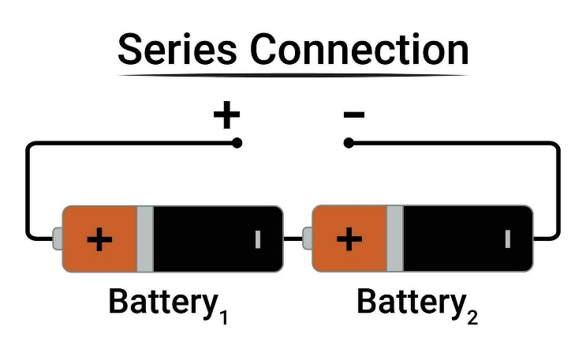
V_total = V1 + V2 + ⋯ + Vn​
- The current remains the same as that of a single battery.
I_total= I1 = I2 = ⋯ = In​

Parallel Combination:
- In parallel combination all positive terminals are connected together, and all negative terminals are connected together.
- The voltage remains the same as that of a single battery.

V_total = V1 = V2 = ⋯ = Vn​

- The total current is the sum of the currents of all batteries.
I_total = I1 + I2 + ⋯ + In​
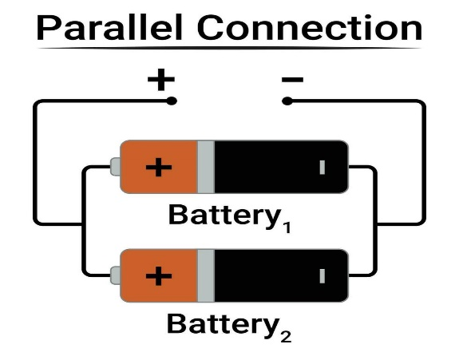

Battery Pack:
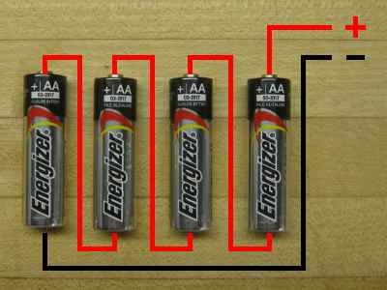
A battery pack is a set of batteries or cells that are connected in series, parallel, or a combination of both, depending on the application's requirements.
EXAMPLE: -
Let us assume a single lithium-ion cell has 3.7V and 2.5Ah
If Four batteries are connected in a series and formed a battery pack find the total voltage and the current?
Then the battery pack has total voltage of 14.8V and total current of 2.5Ah
Battery Bank:
A battery bank is a group of batteries connected in a combination of both series and parallel
Series-Parallel Combination:
  - Purpose: Achieves both increased voltage and capacity.
  - Example: Two sets of 12V, 100Ah batteries in series (24V) connected in parallel will give 24V, 200Ah.
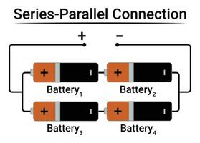

Battery Balancing:
It is a process of equalizing the voltages among individual cells
- Passive Balancing:
  - Excess energy from fully charged cells is dissipated as heat through resistors.
  - Simple but inefficient for large systems.
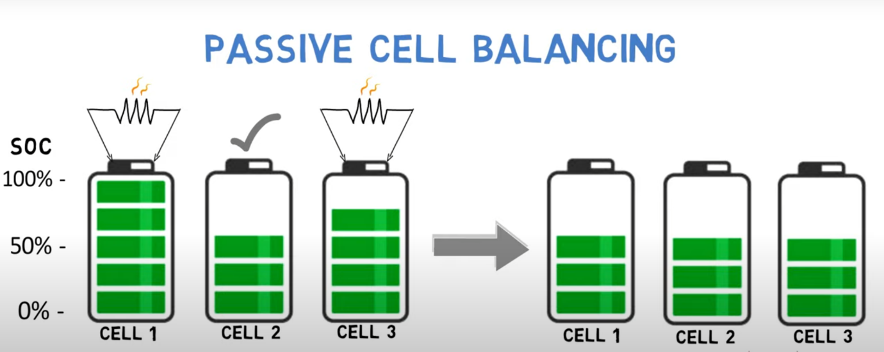

- Active Balancing:
  - Energy is transferred from higher-charged cells to lower-charged ones using circuits.
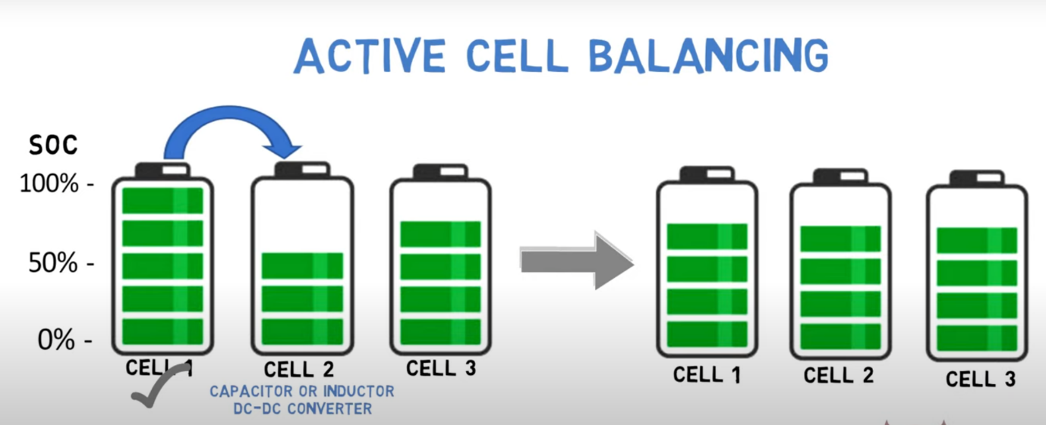
  - More efficient, ideal for high-capacity systems.

Battery Performance Terms:
- SOC (State of Charge):
  - Represents the percentage of the battery's remaining capacity relative to its full capacity.

  - Formula:
SoC (%) = (Remaining capacity / Maximum capacity) x 100.

- SOD (State of Discharge):
  - The percentage of the battery's discharged capacity relative to its full capacity.
  - Formula:
SOD (%) = 100 – SOC

- SOH (State of Health):
  - Indicates the battery's health or performance compared to when it was new.
  - Formula:
SOH (%) = (Current Full Capacity / Initial Full Capacity) ​× 100

- DOD (Depth of Discharge):
  - The percentage of the battery's capacity that has been used relative to its full capacity.
  - Formula:
DOD (%) = (Discharged Capacity / Full Capacity)​×100
OR
DOD (%) = 100 − SOC
- SOP (State of Power):
  - The battery's ability to deliver power at a specific time, often as a percentage of its maximum power output.
  - Formula:
SOP (%) = (Available Power / Maximum Power) ×100

- ROH (Remaining Operating Hours):
  - The estimated time the battery can continue to operate at its current discharge rate.
  - Formula:
ROH (hours) = Remaining Capacity / Current Load​

Example:
Battery Specifications:
  - Total Capacity: 100Ah
  - Original Capacity: 100Ah (when new)
  - Current Full Capacity: 90Ah
  - Remaining Capacity: 60Ah
  - Maximum Power: 500W
  - Available Power: 400W
  - Load Current: 10A
Parameter
  Calculation
  Value
SOC | (60​/100) ×100 | 60%
 | 100−60 | 40%
  SOD
SOH | (90/100)​×100 | 90%
DOD | 100−60 | 40%
 | (160​/200) × 100 | 80%
  SOP
ROH | 60/10 | 6 hours

